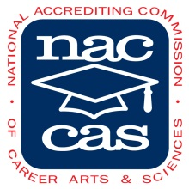
THOMPSON SCHOLARSHIP FUND APPLICATION
For the counties of Augusta, Highland & Nelson and the cities within

Each year Staunton School of Cosmetology offers scholarships. To be eligible for these scholarships you must follow the scholarship guidelines for the counties in which you reside and complete the application below.

NAME:
PERMANENT ADDRESS:
CITY:
STATE: ZIP:
EMAIL:
HOME PHONE: CELL PHONE:

Why have you chosen Cosmetology as a career?

What are you career goals?

May not be used with any other Staunton School of Cosmetology Scholarships.

